Khushi Sharma

BCA 1B (AIML)

Group 2

Assignment-1

Q1- Create a simple HTML page using basic tags.

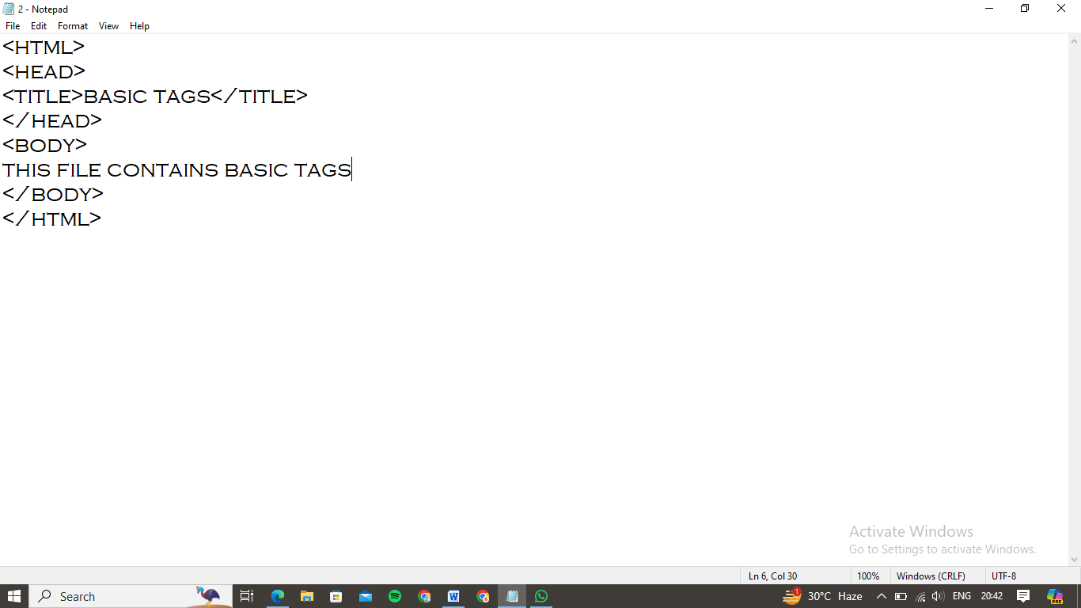

Output:

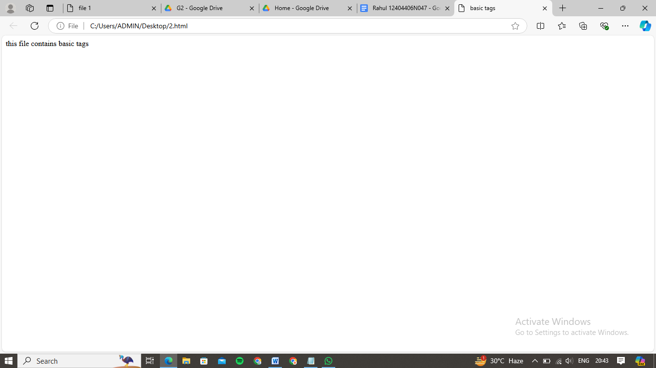

Q2- Create a webpage that displays your name to the screen.

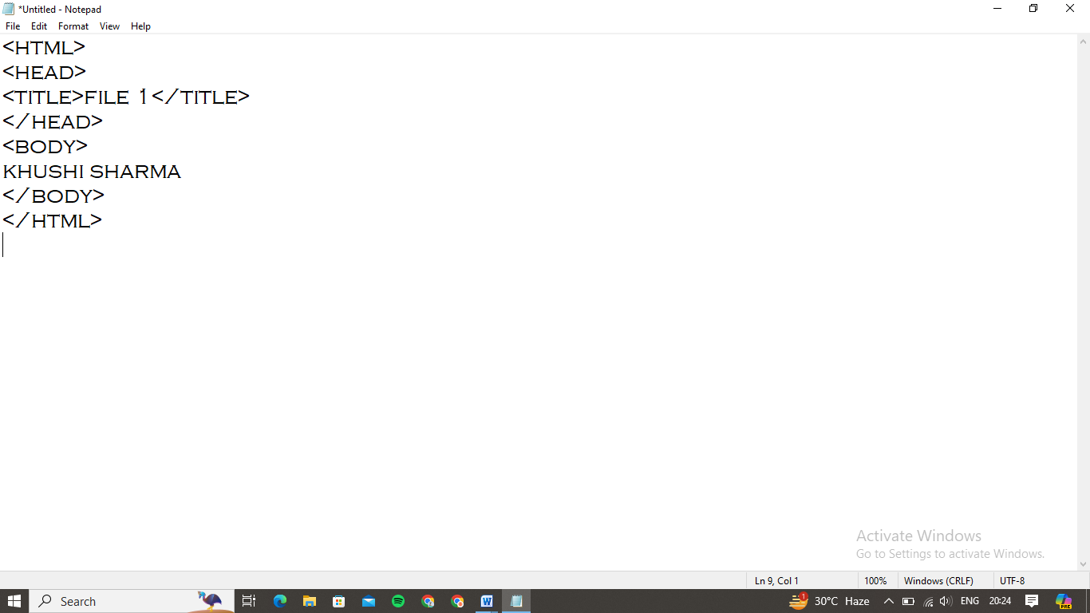

Output:

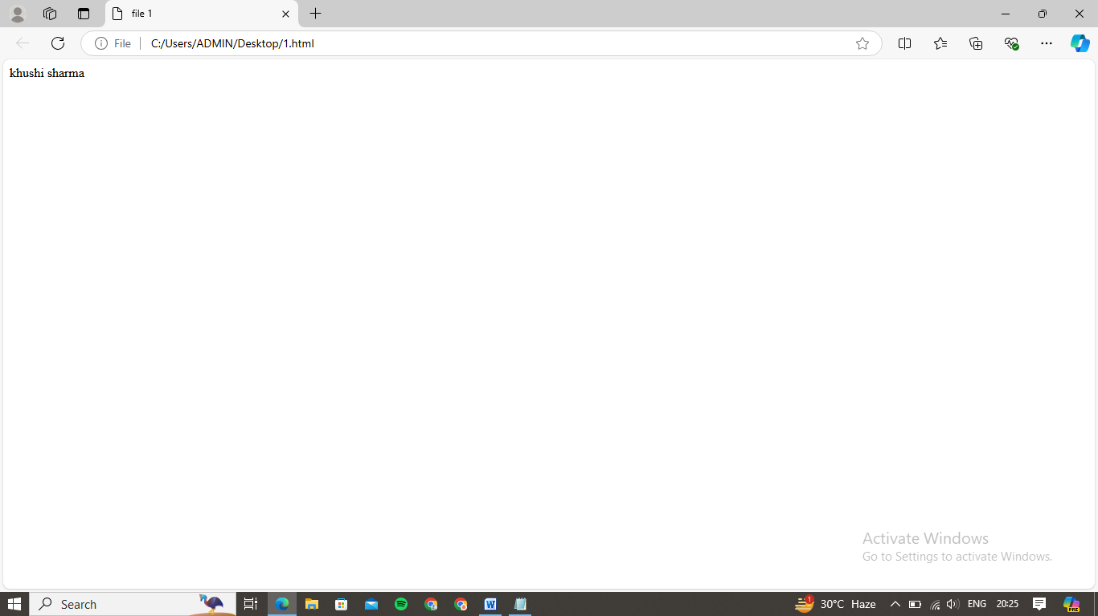

Q3- Create a webpage and show the output from 1 to 10 in separate lines.

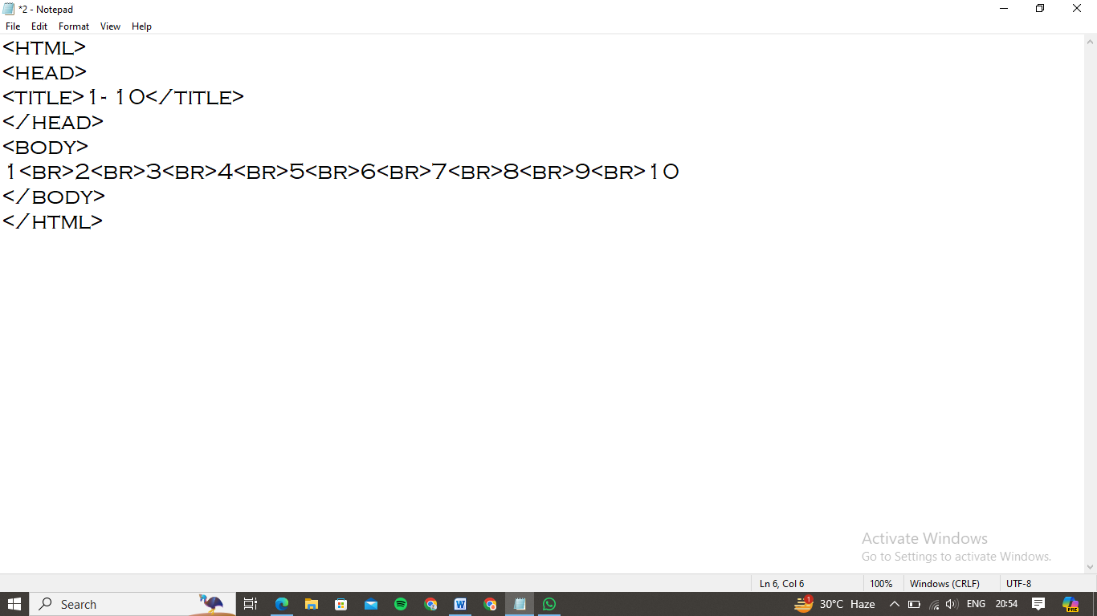

Output:

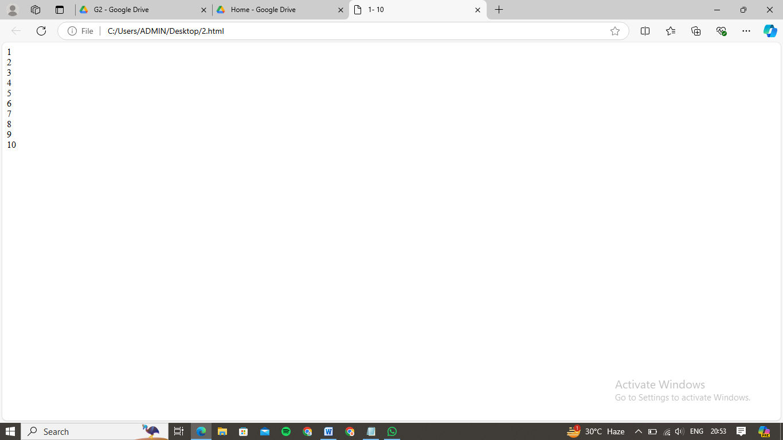

Q4- Create a webpage and show the output from 1 to 10 in separate lines, each number being in different color.

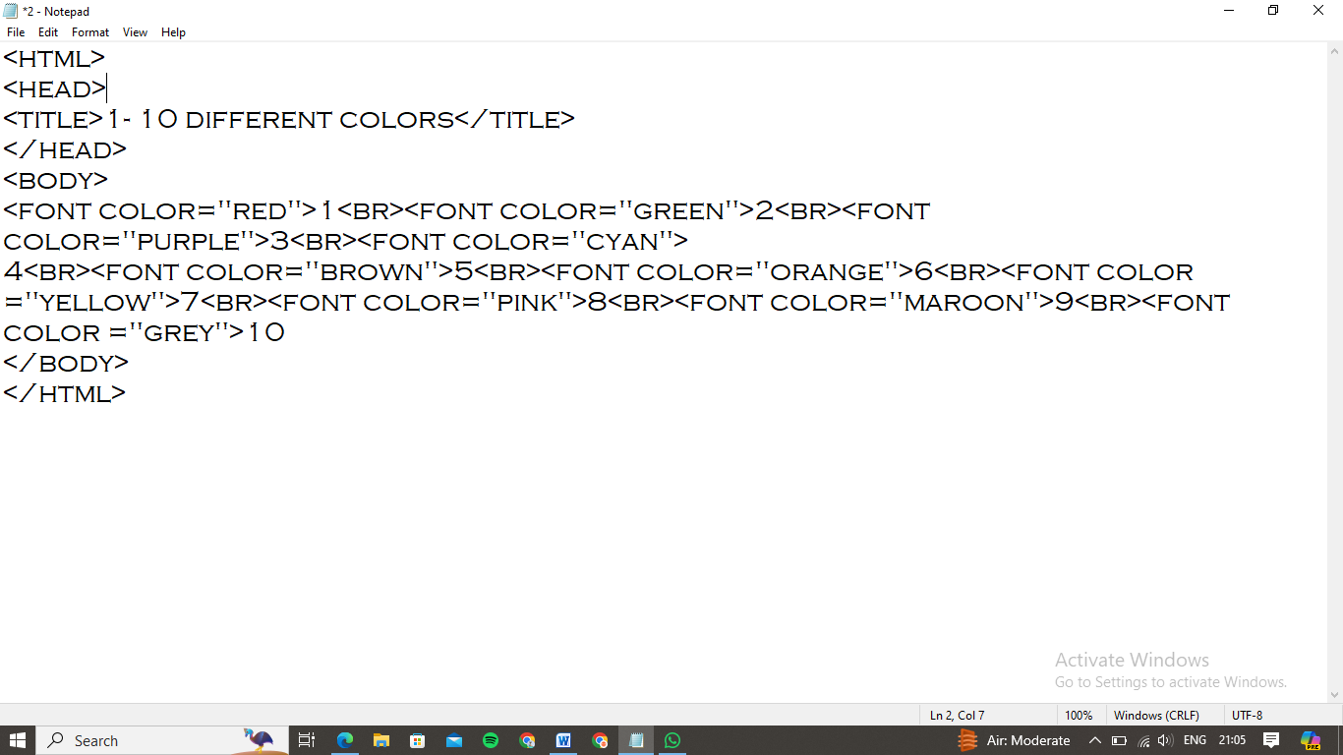

Output:

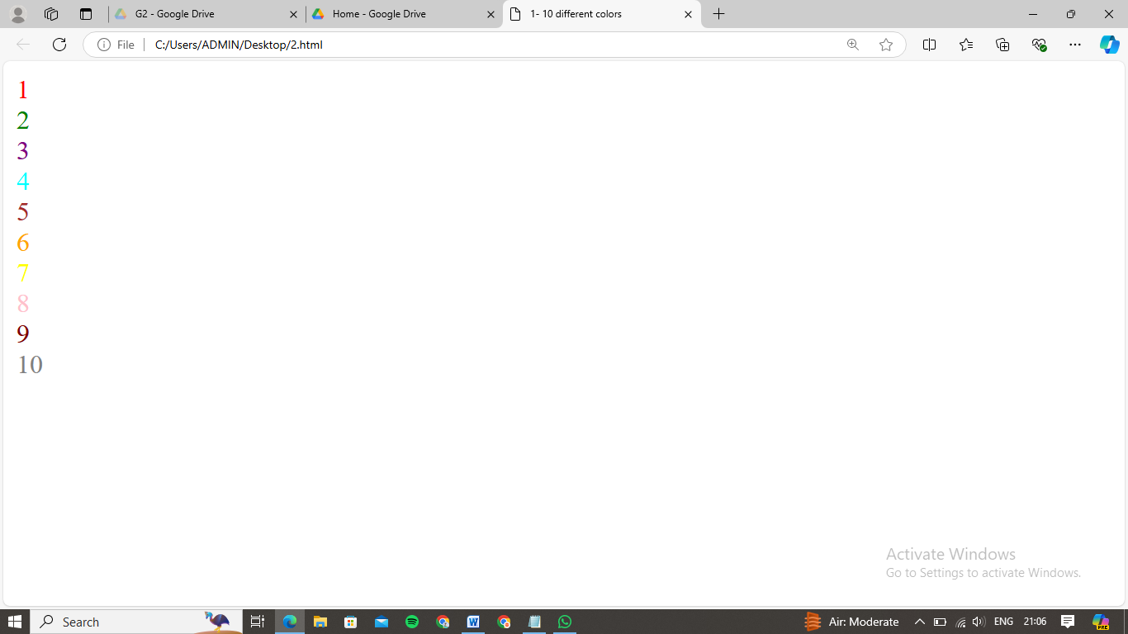

Q5- How do I make a picture as a background on my webpage?

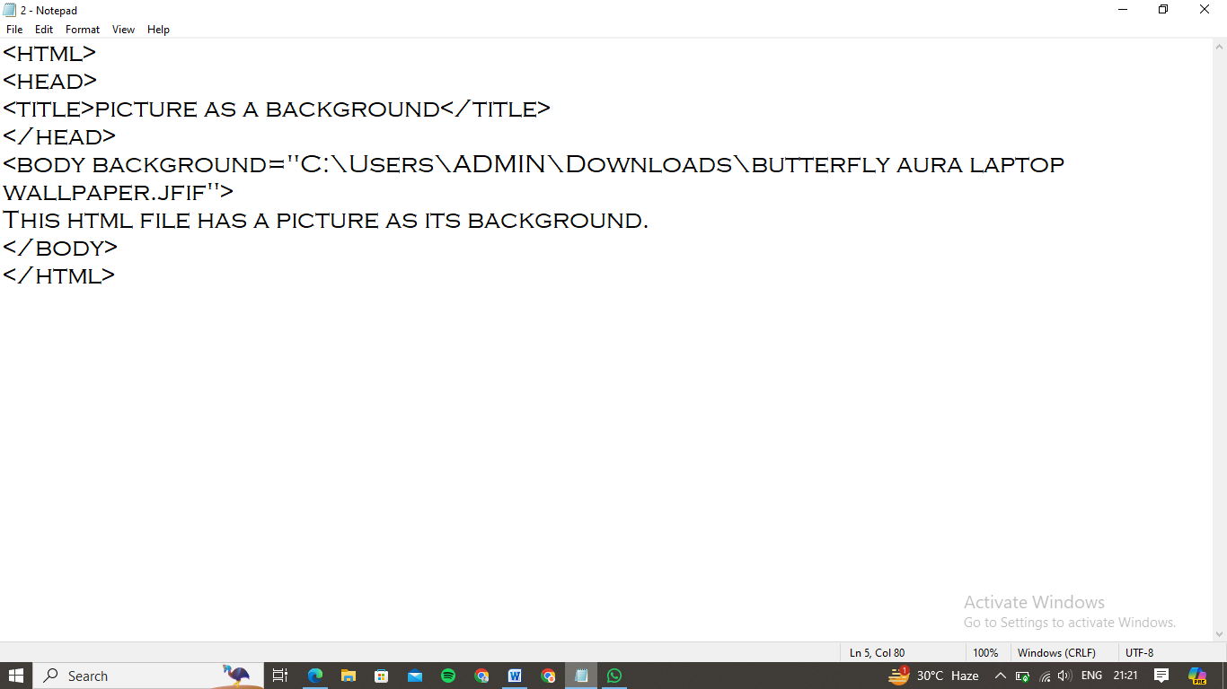

Output:

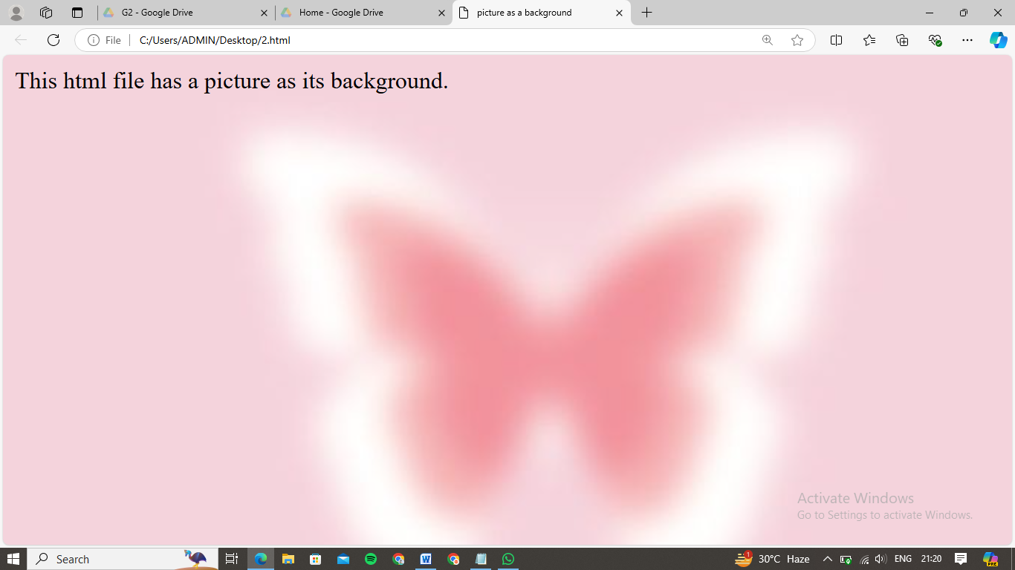

Q6- Create a webpage to print a paragraph with 4-5 sentences, each sentence shall have a different font.

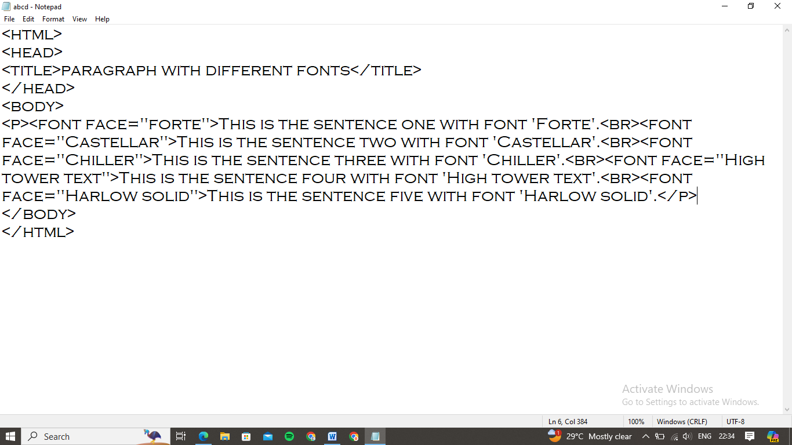

Output:

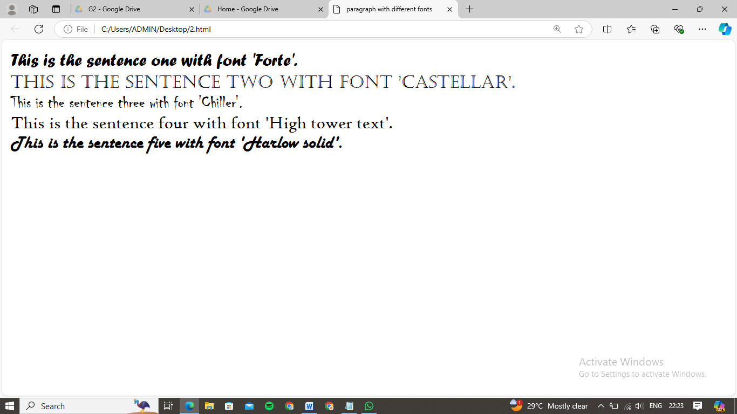

Q7- Write an HTML code to print a paragraph that is description of a book, it shall include the title of the book, the author’s name; name and title should be underlined and all adjectives shall be bold and italics.

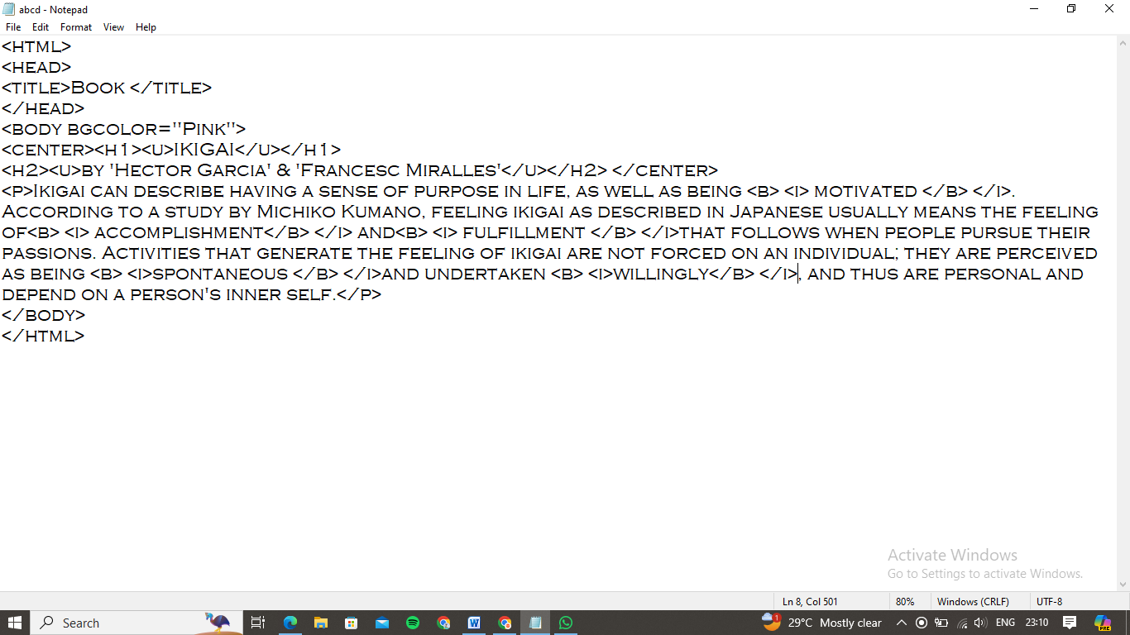

Output:

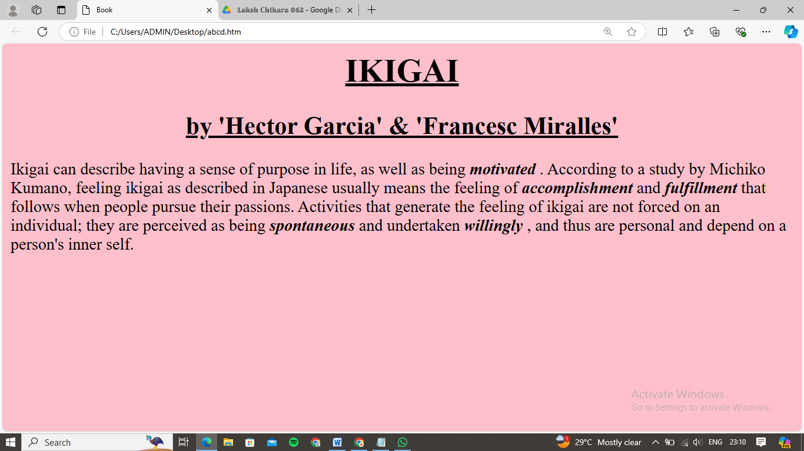

Q8- Write an HTML code to print your name using heading tag, every letter shall be of different heading size.

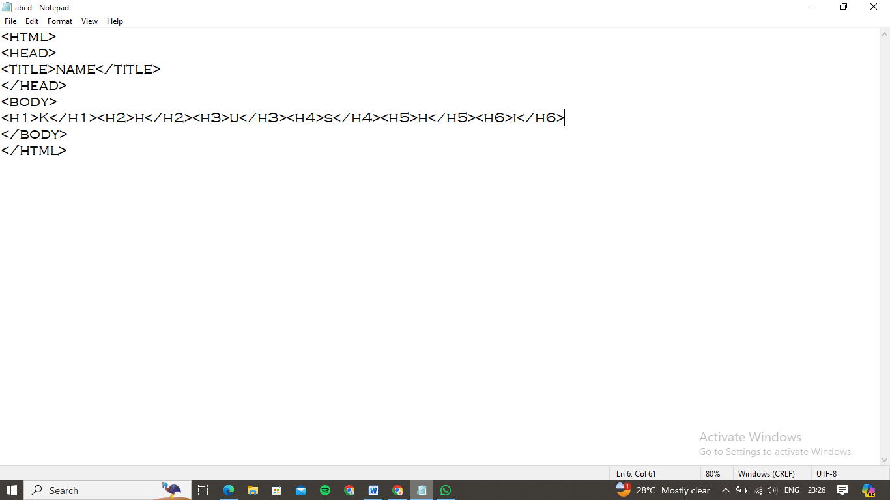

Output:

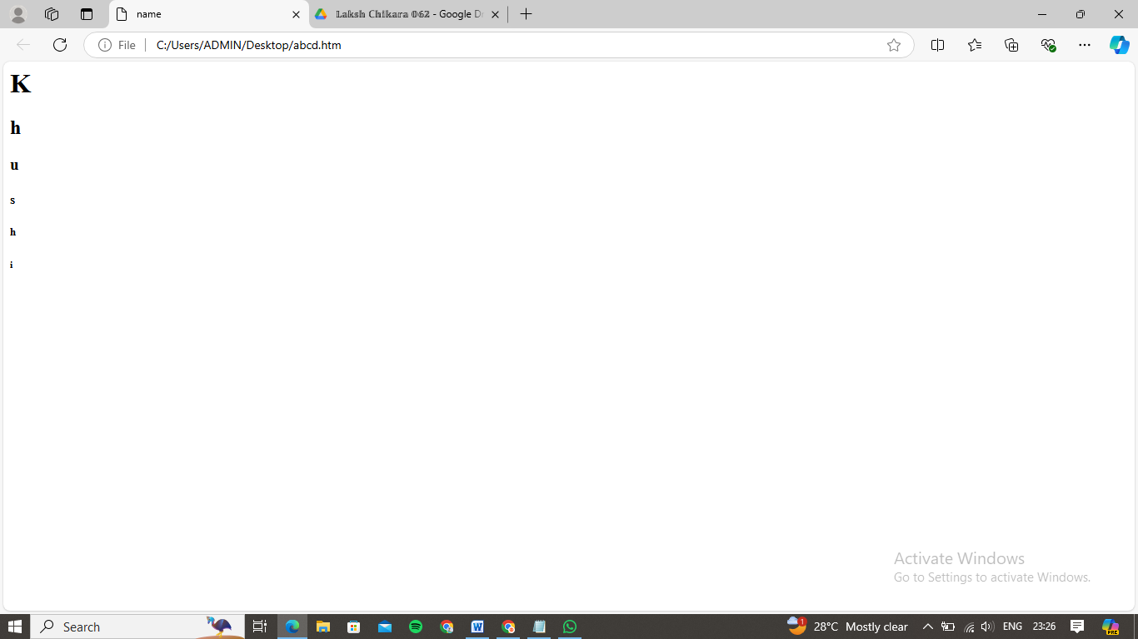

Q9- Write an HTML code to print the sequence of numbers from 1-20. Each number shall be in different line with number 2 next to it as a subscript, an equal sign and the result.

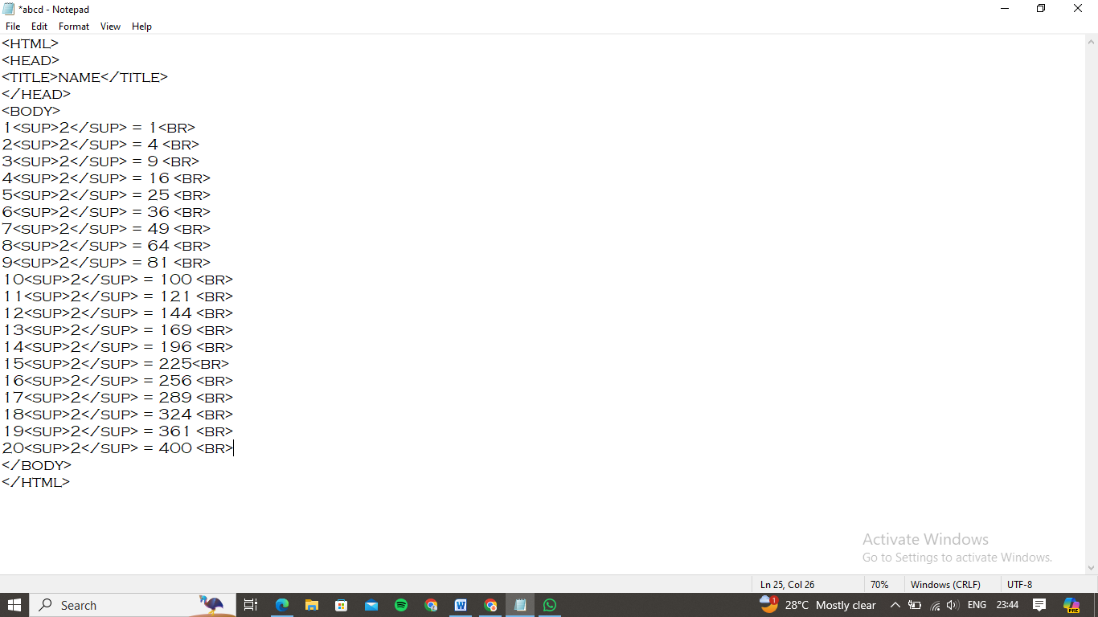

Output:

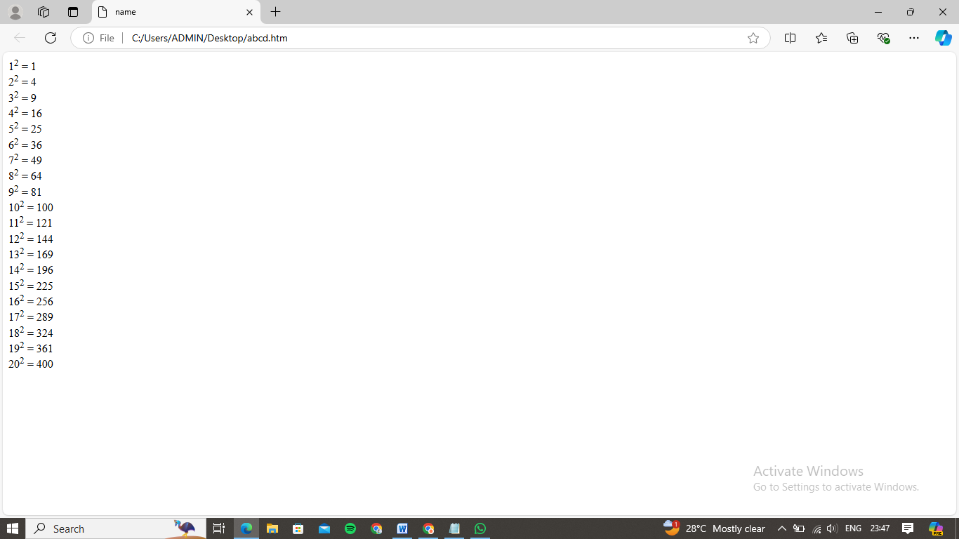

Q10- Write an HTML code to display an image with border of size with width 200, height 200 pixels, leaving ‘H’ space and ‘V’ space of your choice with image hanging in the right side on the screen.

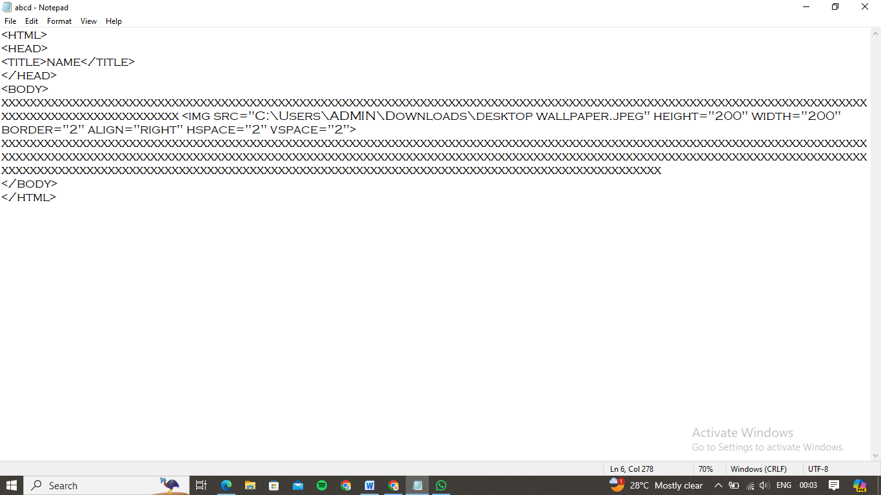

Output:

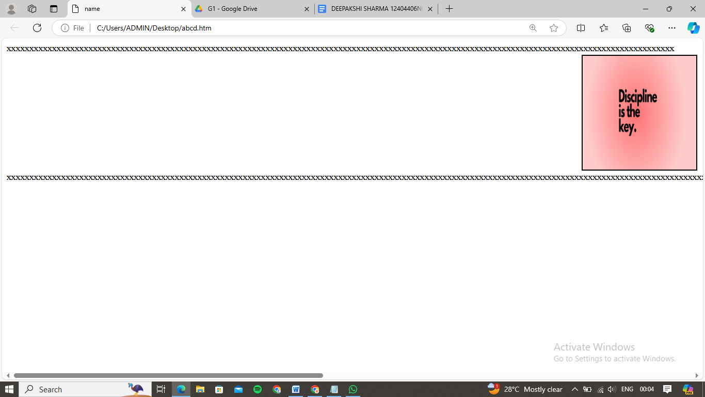

Q11- Write an HTML code to create a webpage with a heading. The heading shall be displayed at the top centre of the page and the image shall be at the centre, just below the heading.

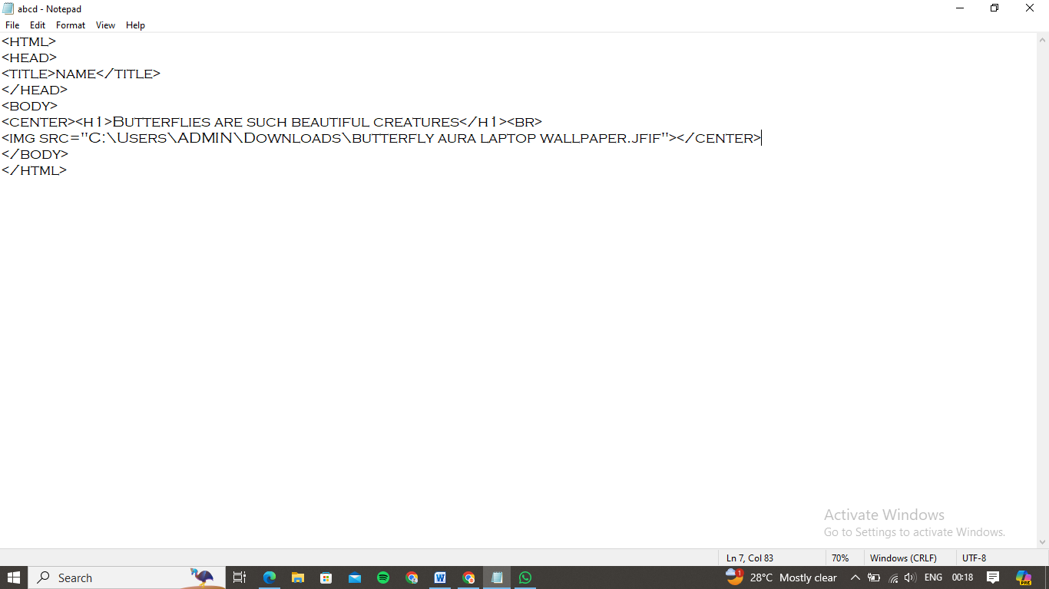

Output:

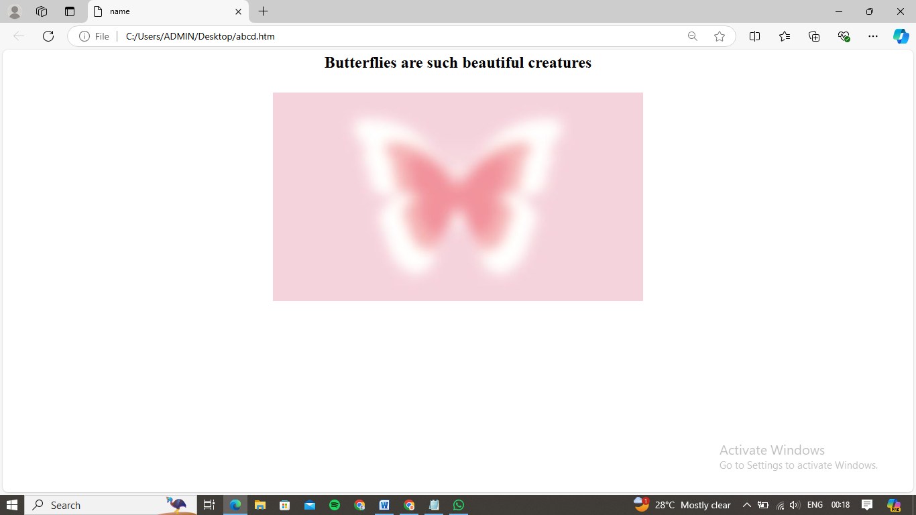

Q12- Write an HTML code using multimedia tags.

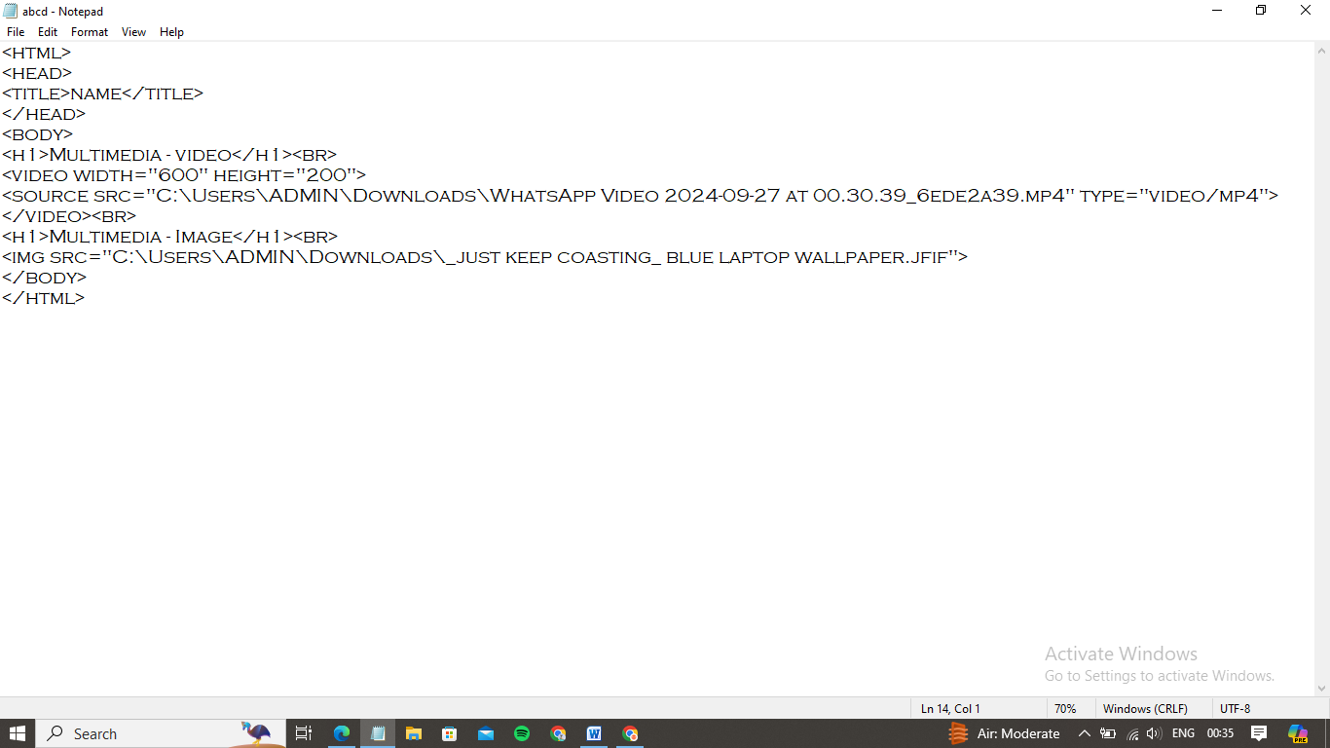

Output:

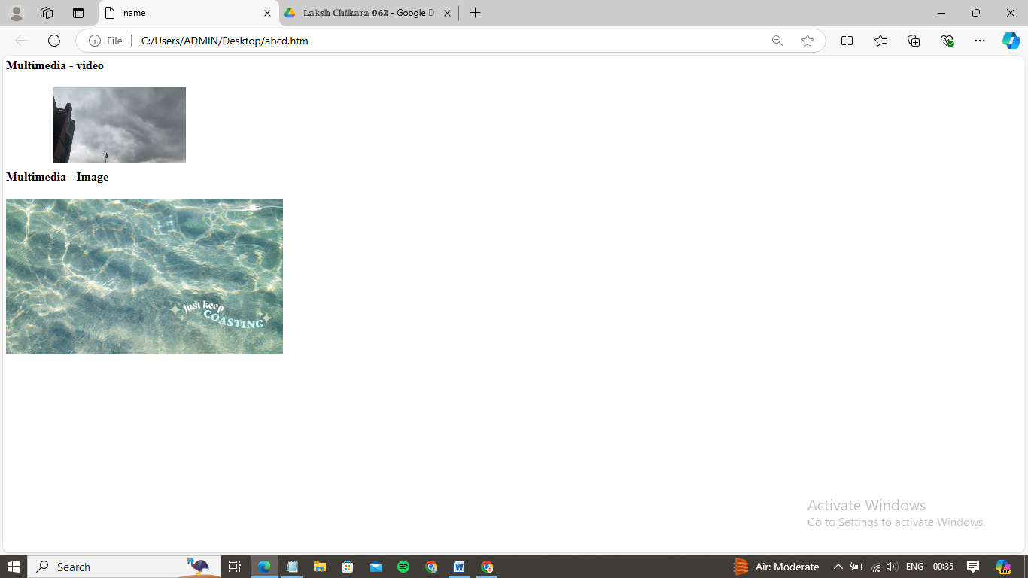

Q13- Create a table using row span and col span, taking examples of students’ record.

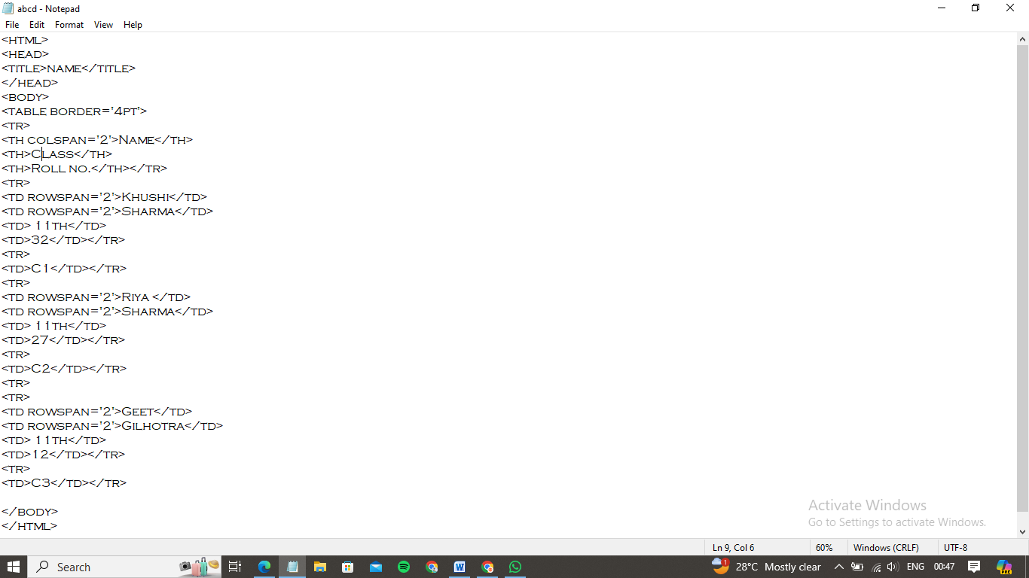

Output:

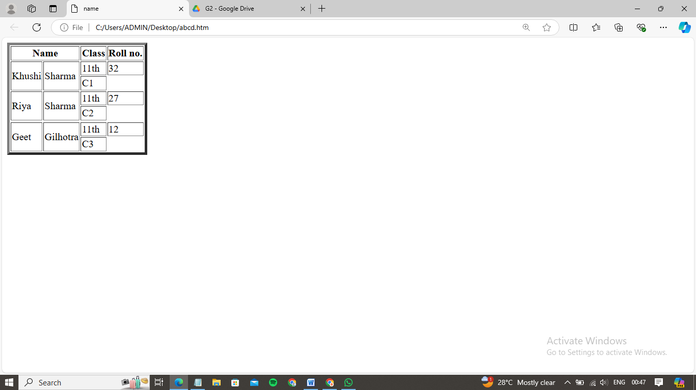

Q14- Write an HTML code using table tag, cell padding and cell spacing as its attributes.

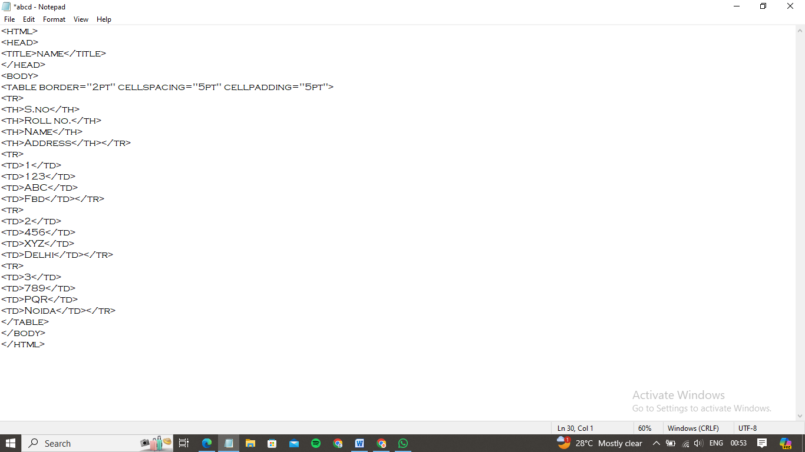

Output:

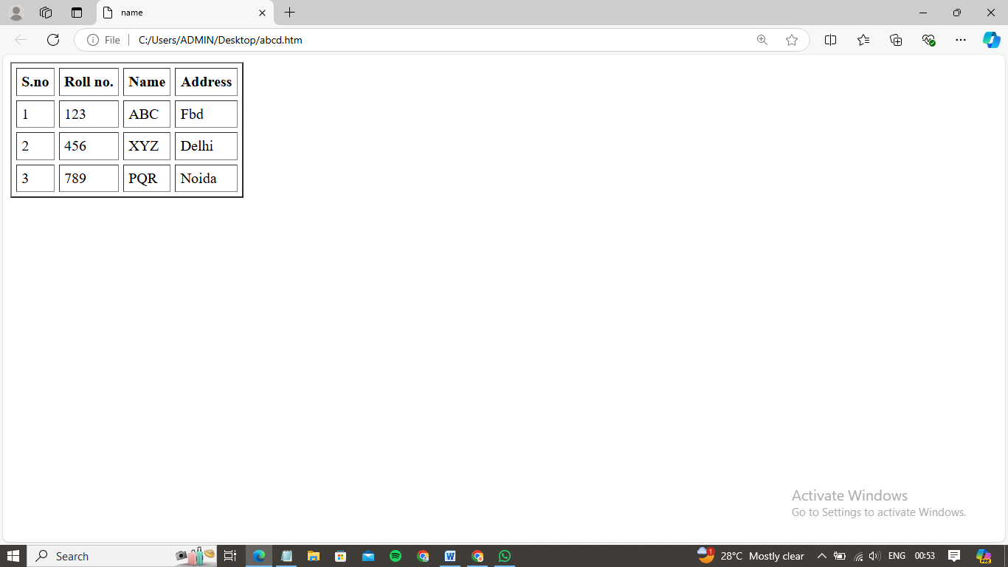

Q15- Create an ordered, unordered and definition list, taking example of your subjects in MCA 1st, 2nd &3rd semester.

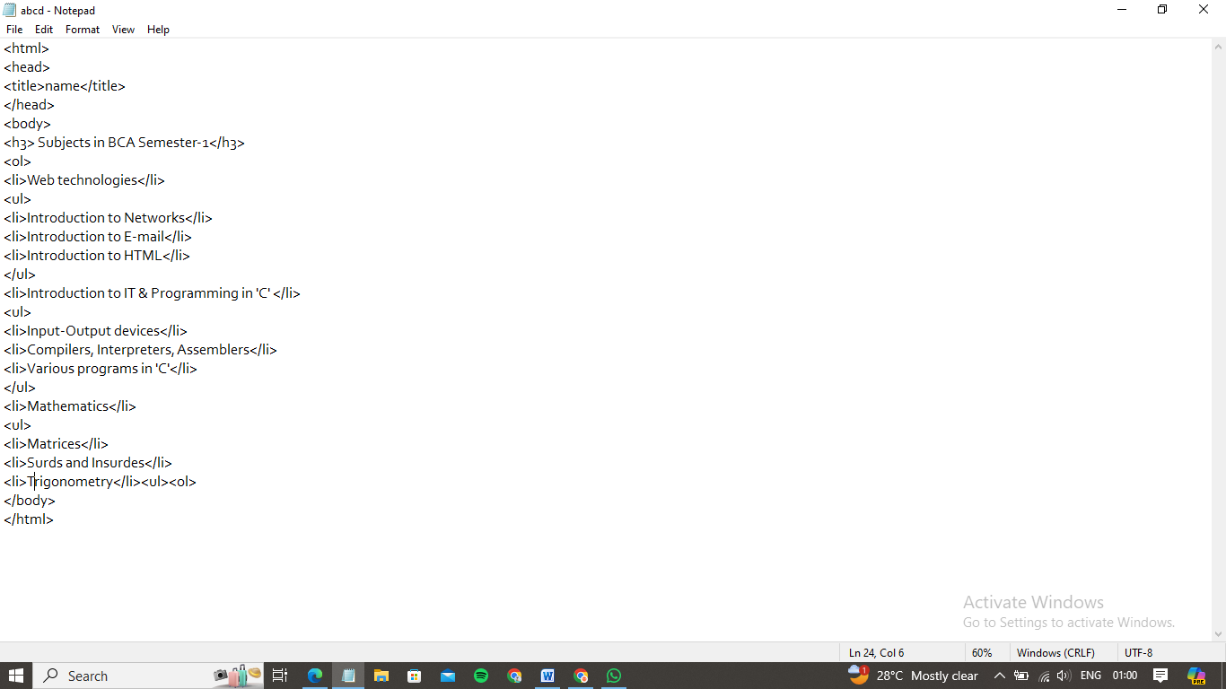

Output:

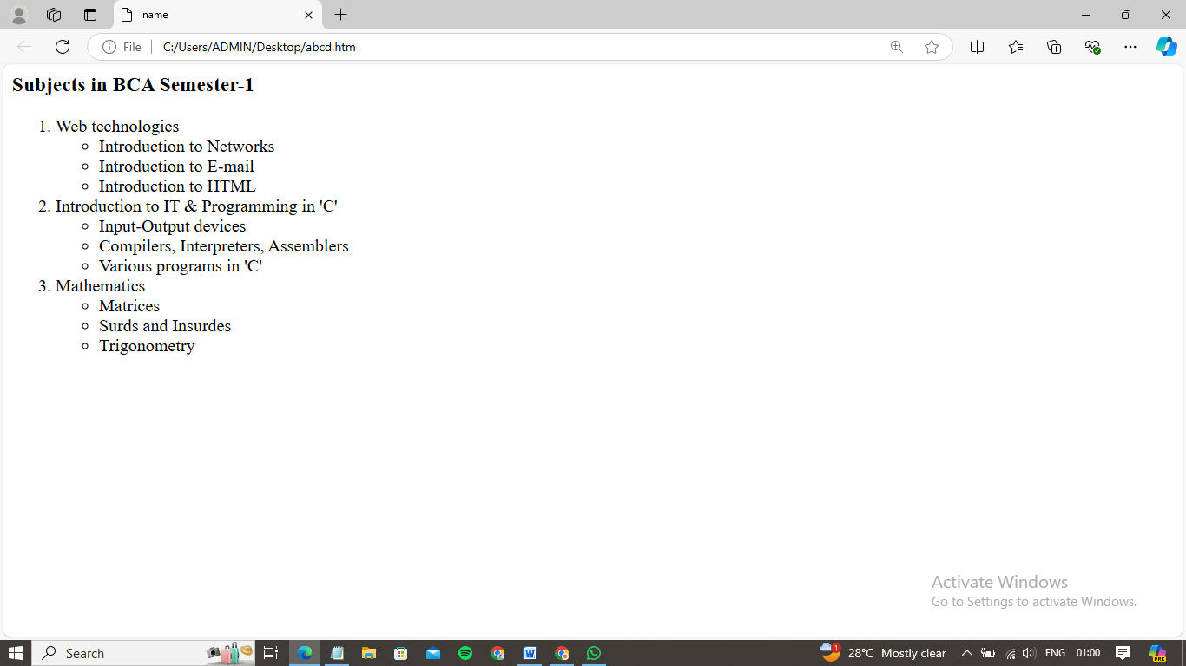

Q16-Write HTML code using <frameset>and<frame> tag with all its attributes.

Input:

Output:

Q17-Write HTML code to design a form in HTML using controls and buttons such as Teaxtbox, Textarea, password, submit button, browse button, drop-down menu.

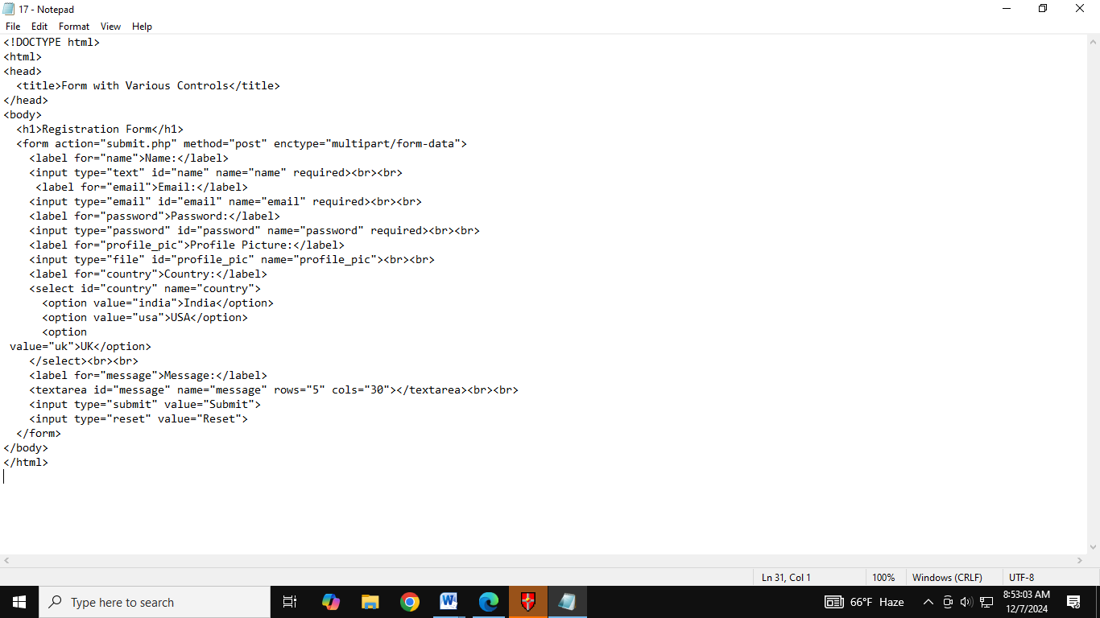

Output: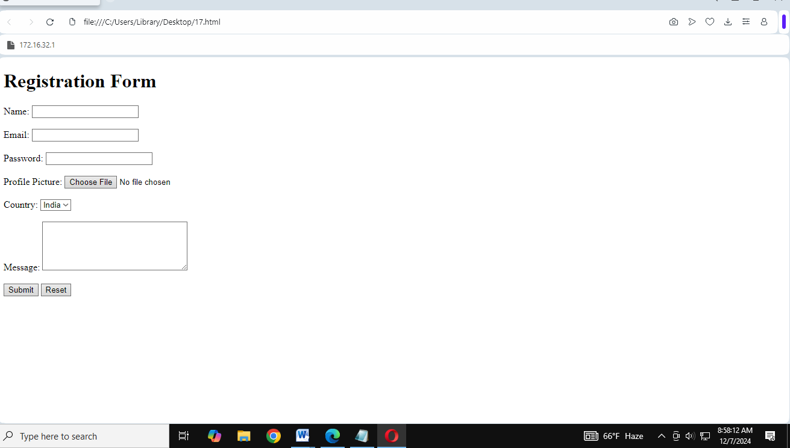

Q18-Write HTML code to design a Registration Form in HTML.

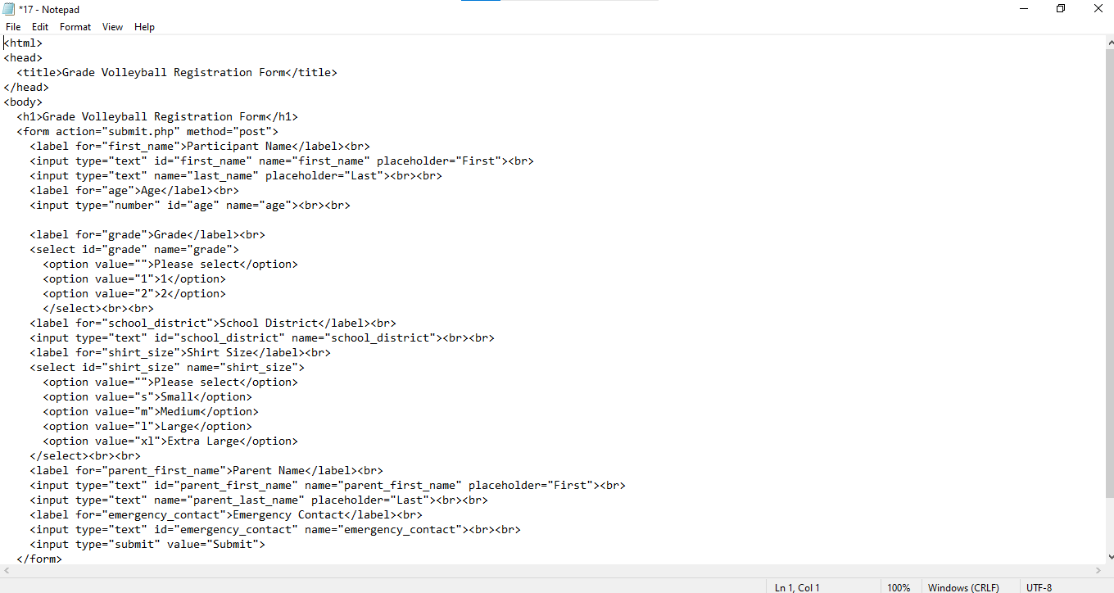

Output: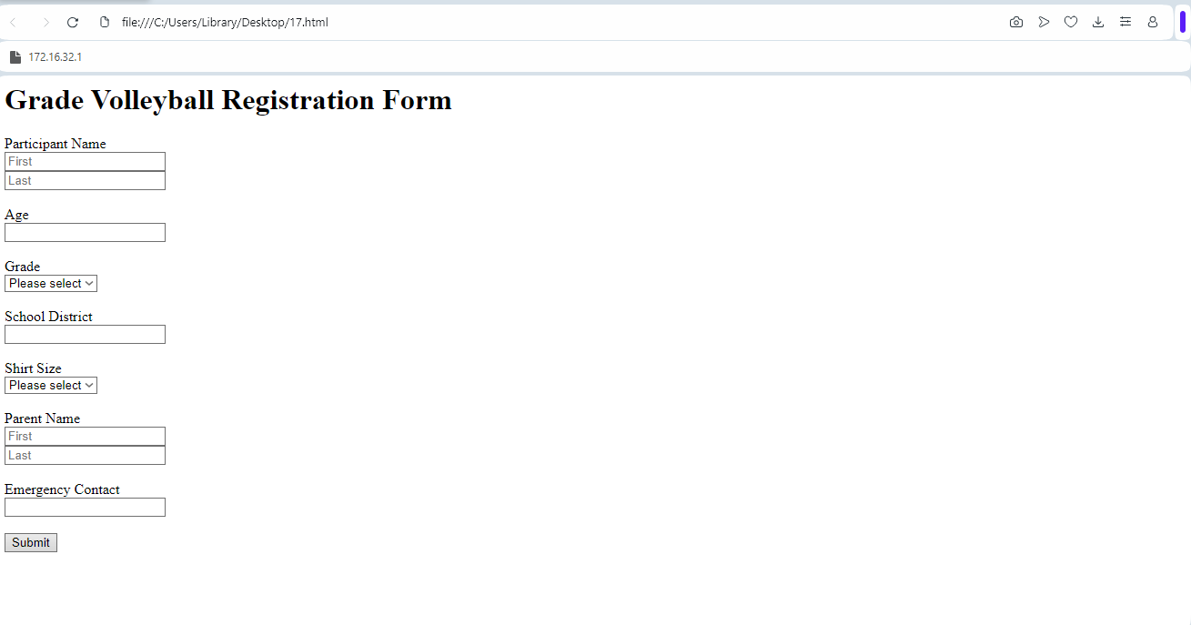

Q19-Write HTML code to design a student admission FORM in HTML.

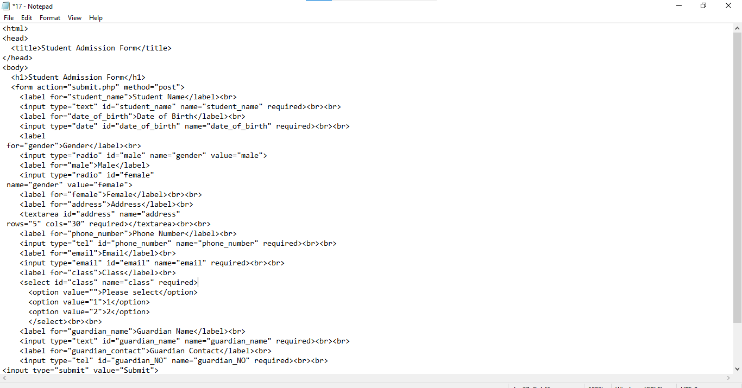

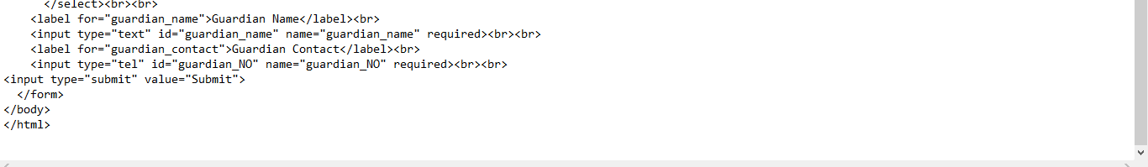

Output: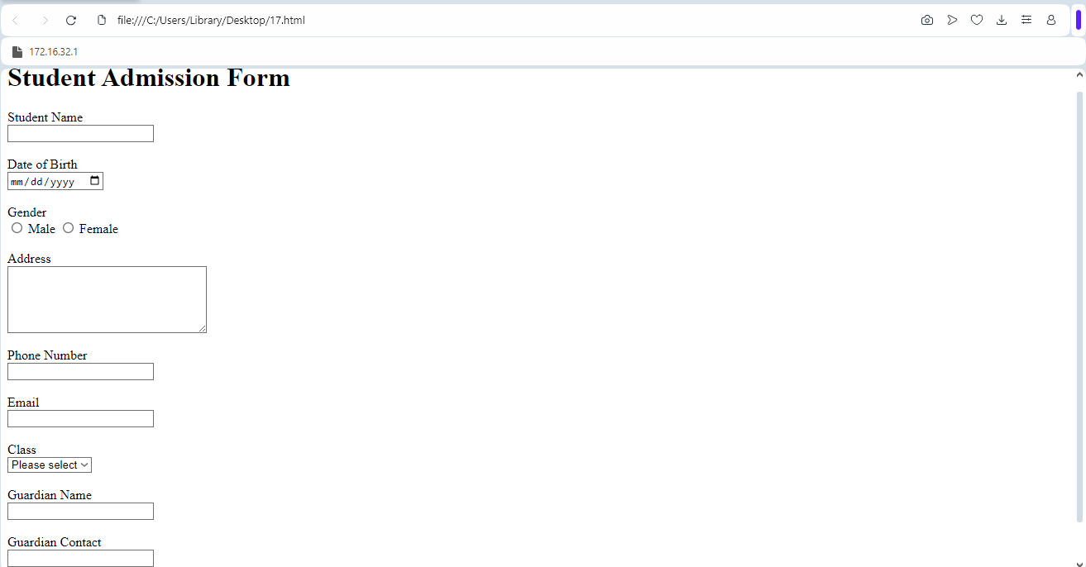

Q20-Create a proper home page of your own using any components and styles.

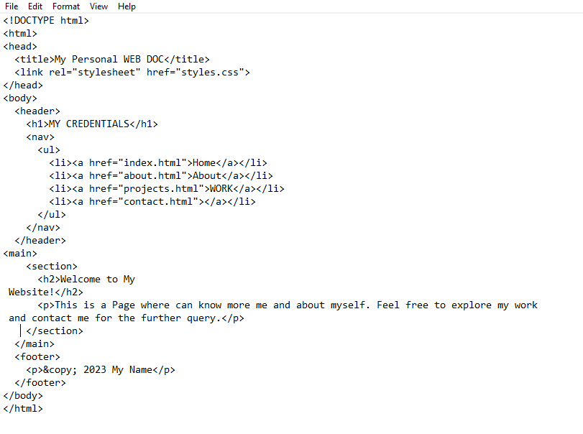

Output: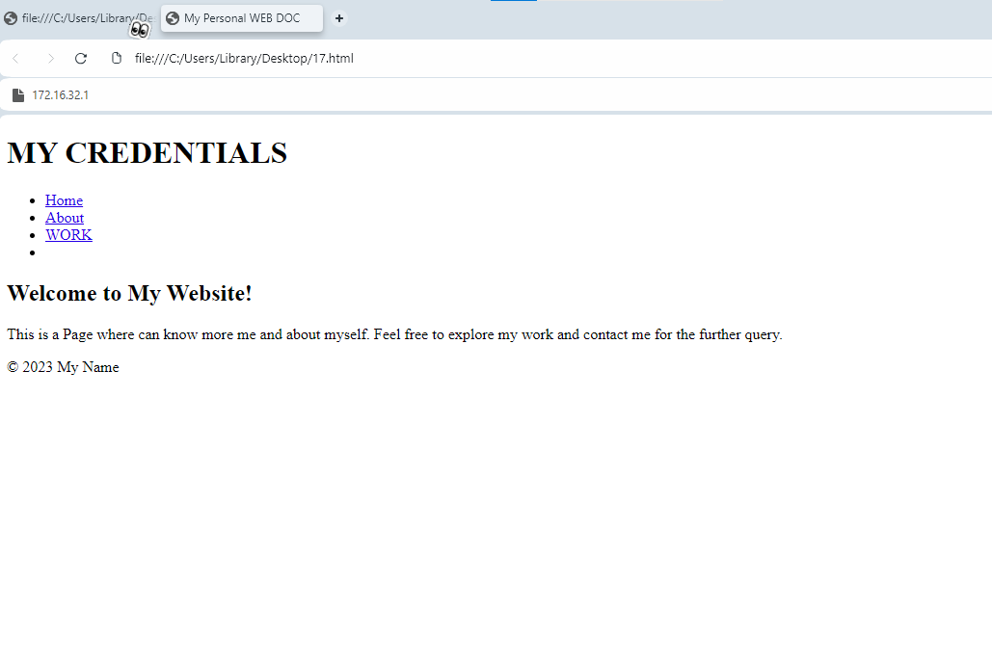

Q21-Write HTML code for including Local Hyperlinking in a web page.

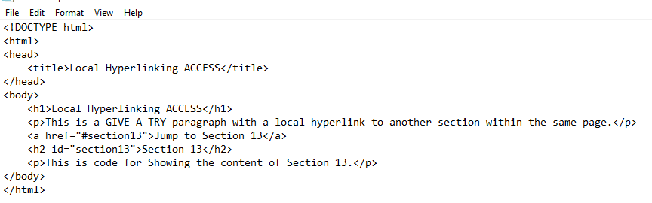

Output:Write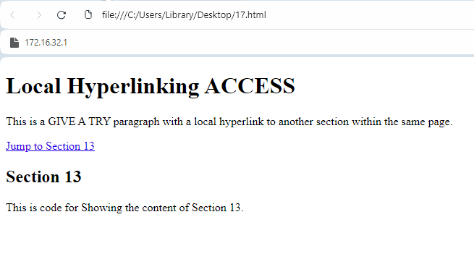

Q22-Write HTML code for including Inter hyperlinking in a web page.

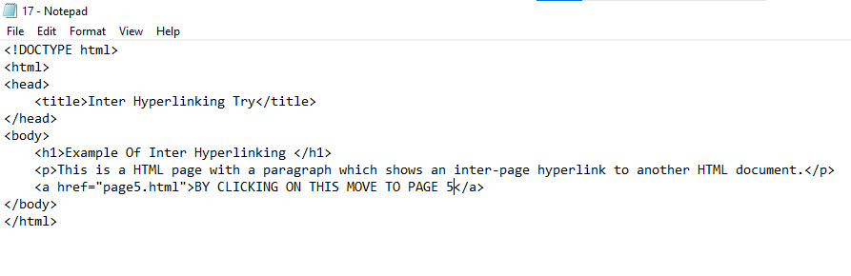

Output: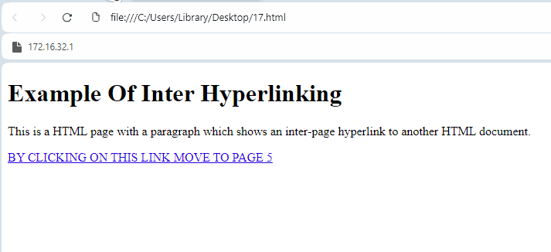

Q23-Write HTML code for including External Hyperlinking.

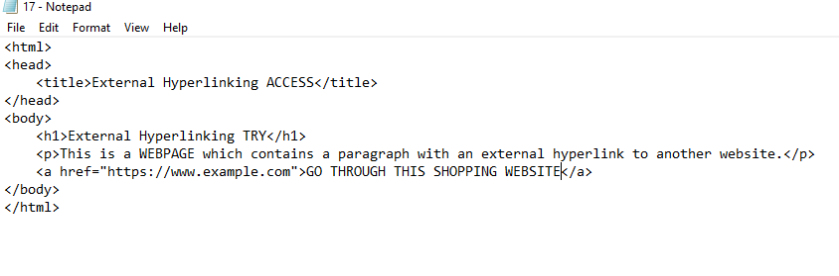

Output: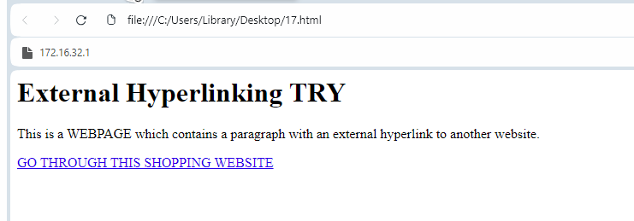

Q24-Write code to show External CSS with HTML code.

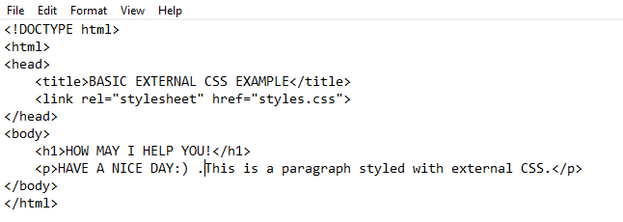

Output: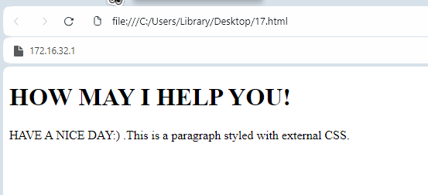

Q25-Write a code to show Internal CSS with HTML code.

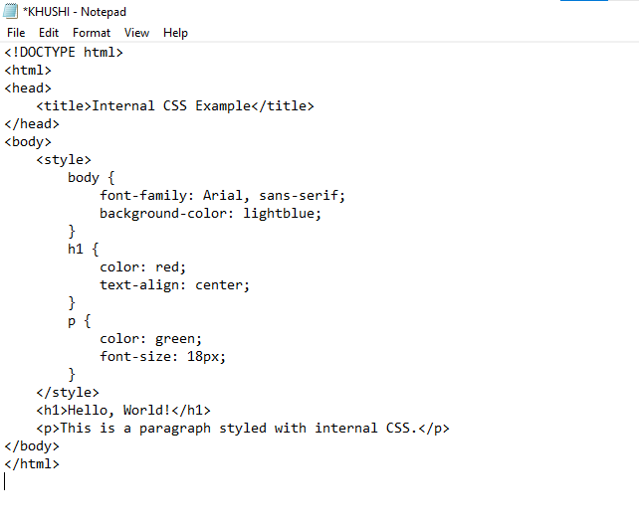

Output: 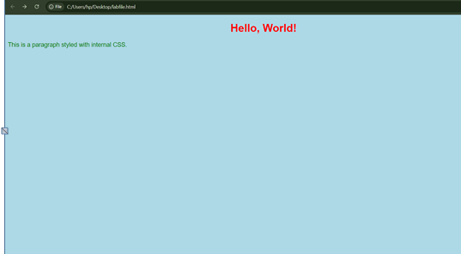

Q26-Write code to show Inline CSS with HTML code.

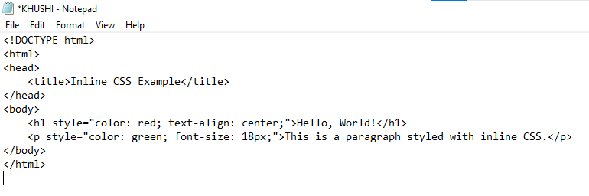

Output: 